**Supplemental Materials**

Optical Sensors to Predict Sugarbeet Yield, Quality, and Fertilizer Nitrogen Application Rate

Laura L. Van Eerdz, J. Mitchell MacFarlane, and Inderjot Chahal

School of Environmental Sciences, Univ. of Guelph, Ridgetown Campus, Ridgetown, ON, Canada N0P 2C0

zCorresponding author: [lvaneerd@uoguelph.ca](mailto:lvaneerd@uoguelph.ca).

**Table S1** Impact of fertilizer N rate, cultivar, and harvest date on surface (30 cm) soil mineral N (sum of nitrate-N and ammonium-N) at sugarbeet harvest in 2015 to 2017.

|  |  |  |  |
| --- | --- | --- | --- |
| Treatment | Soil mineral N (kg N ha-1) | | |
| N fertilizer rate (kg N ha-1) | 2015 | 2016 | 2017 |
| 0 | 69.3 | 43.8 | 37.9 |
| 90 | 69.4 | 46.4 | 39.4 |
| 224 | 75.0 | 62.0 | 58.2 |
| Cultivar (C) |  |  |  |
| B1399 | 67.9 | 49.2 | 36.8 |
| CRR059 | 73.0 | 55.8 | 53.7 |
| SX-1235N* | 72.7 | 47.1 | 45.0 |
| Harvest date (H) |  |  |  |
| Early | 39.2 b | 46.1 | 37.1 b |
| Late | 103 a | 55.0 | 53.2 a |
| Effects | *P values* | | |
| C | 0.5530 | 0.4580 | 0.1368 |
| N | 0.3934 | 0.0955 | 0.1119 |
| C x N | 0.4827 | 0.5972 | 0.3406 |
| H | **<0.0001** | 0.0964 | **0.0053** |
| C x H | 0.2286 | 0.3111 | 0.9438 |
| N x H | 0.2841 | 0.6101 | 0.3441 |
| C x N x H | 0.6388 | 0.7083 | 0.9267 |

a-bFor each source of variation, different letters reflect a significant statistical difference according the Tukey’s comparative test (*P*<0.05) and indicated in bold font.

*SX-1245N was grown in 2017

**Early Harvest Late Harvest**

A

B

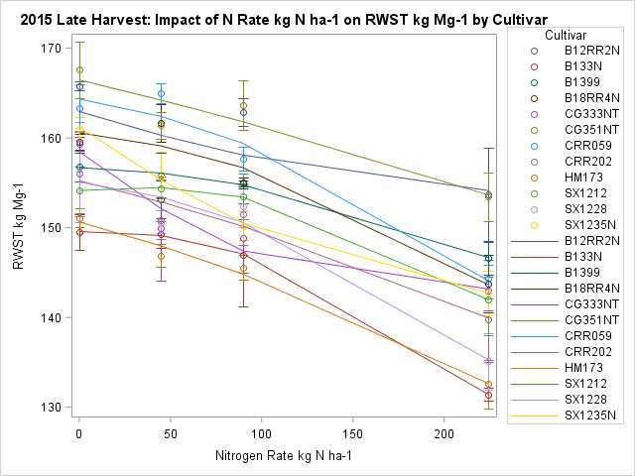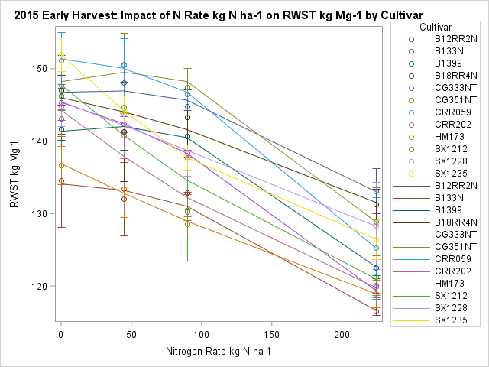

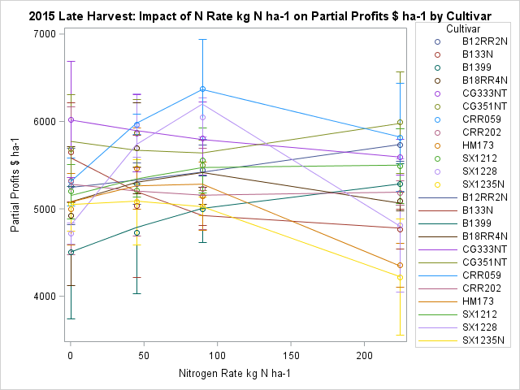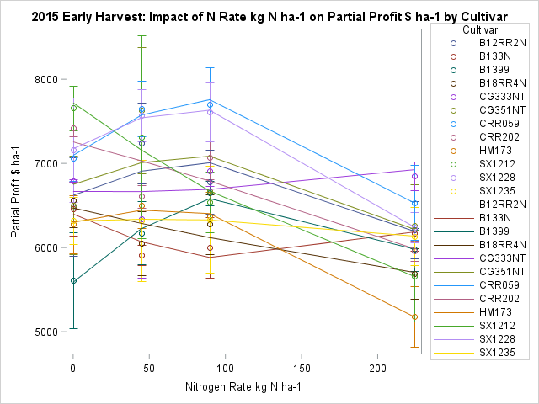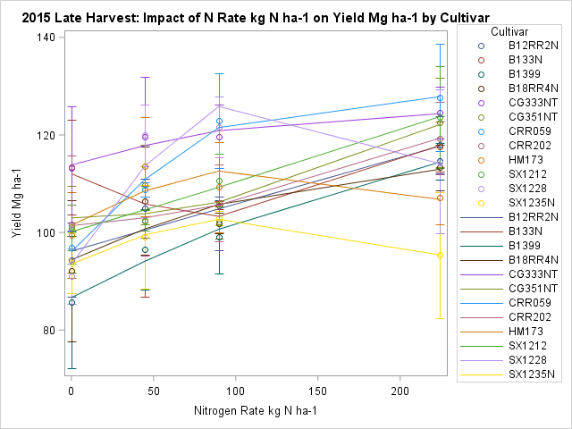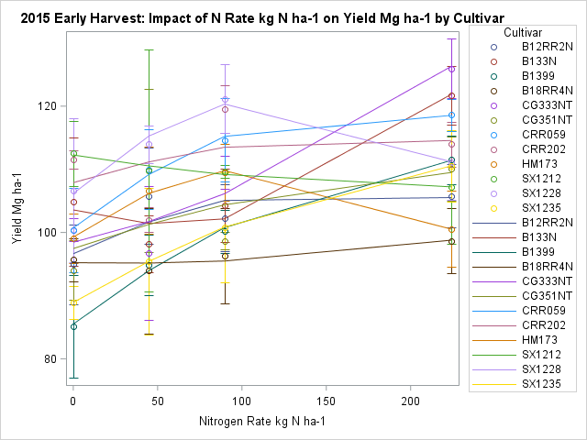

N applied (kg N ha-1)

D

C

E

F

**Fig. S1.** Cultivar response to in-season, injected nitrogen fertilizer based on RWST(A, B), root yield (C, D) and partial profit (E, F) at early (left) and late (right) harvest in 2015.

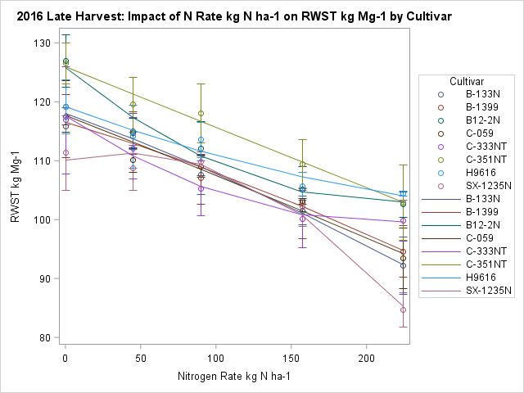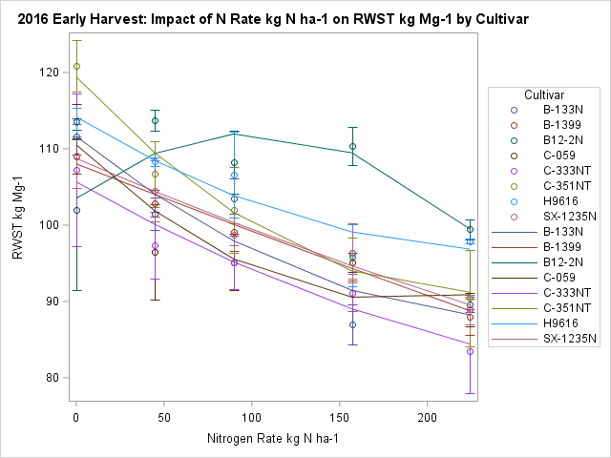

A

B

E

F

**Early Harvest Late Harvest**

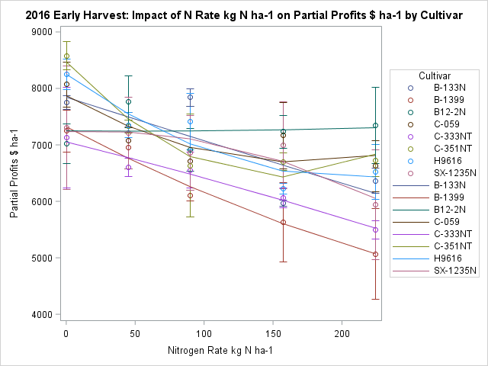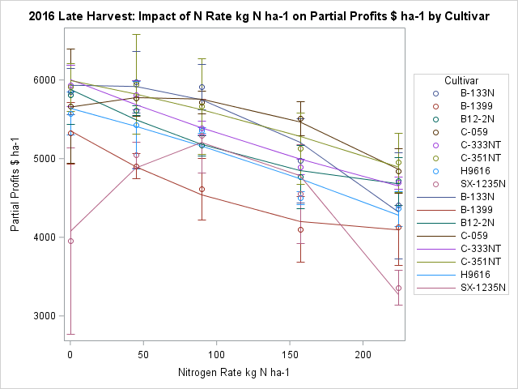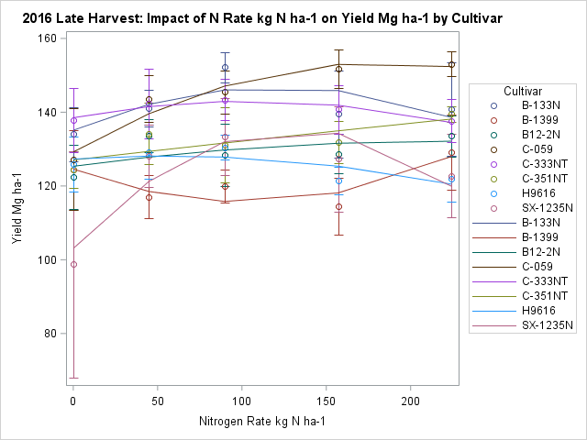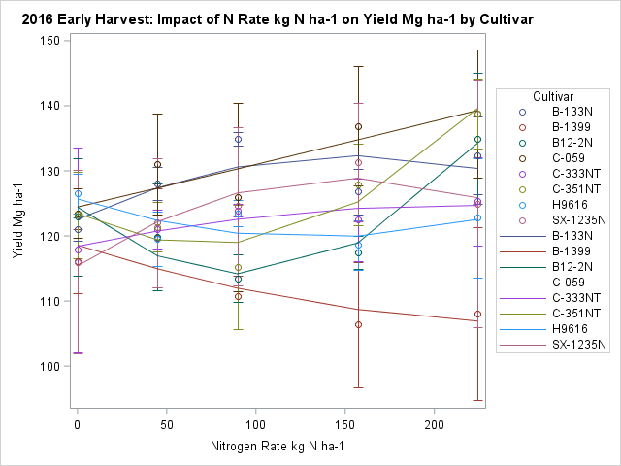

N applied (kg N ha-1)

C

D

**Fig. S2.** Cultivar response to in-season, injected nitrogen fertilizer based on RWST(A, B), root yield (C, D) and partial profit (E, F) at early (left) and late (right) harvest in 2016.

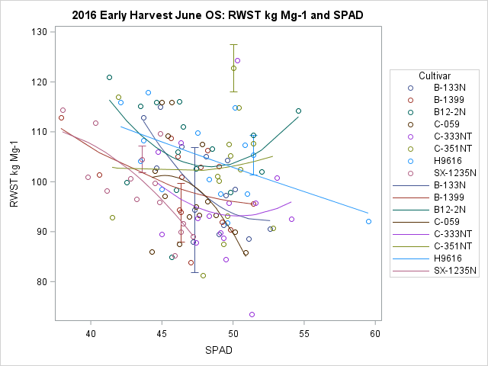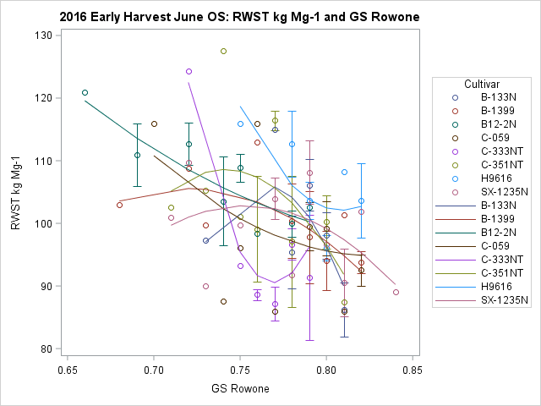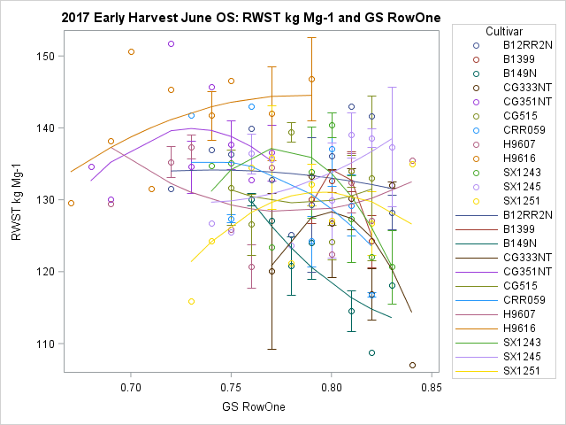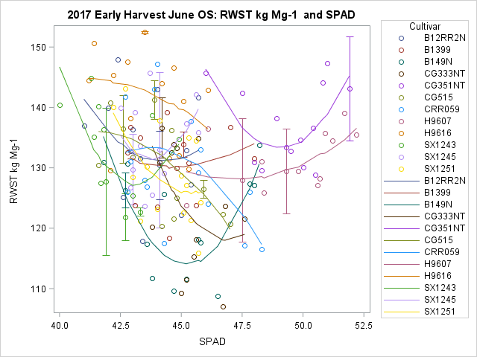

C

A B

D

A

B

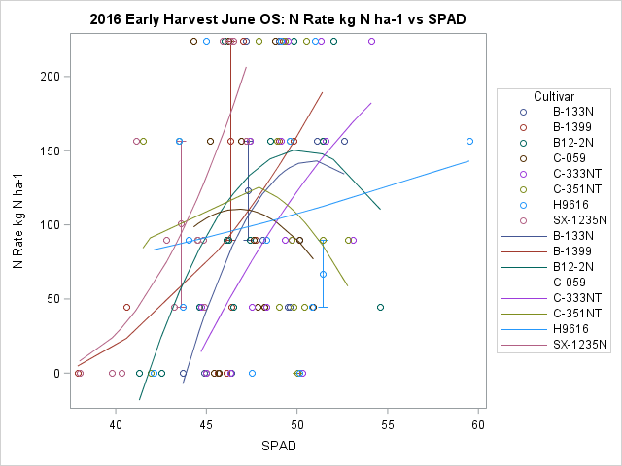

E

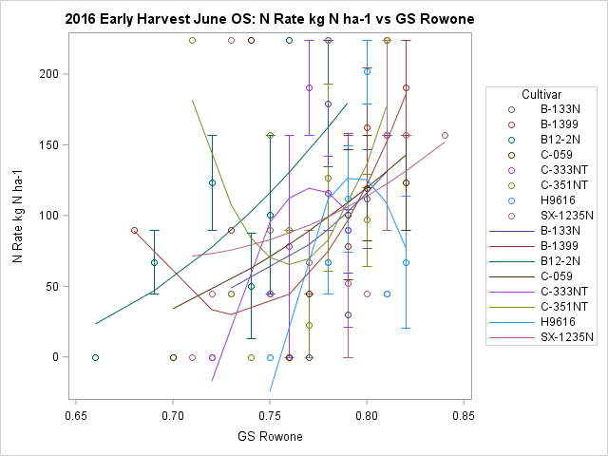

F

SPAD reading Greenseeker reading

**Fig. S3.** Cultivar relationship of optical sensor readings from SPAD meter (left) and Greenseeker (right) taken in June with recoverable white sucrose per tonne (RWST) at early harvest in 2017 (A, B) and 2016 (C, D) and with in-season nitrogen fertilizer (E, F) in 2016. Note the change in scale in each panel.

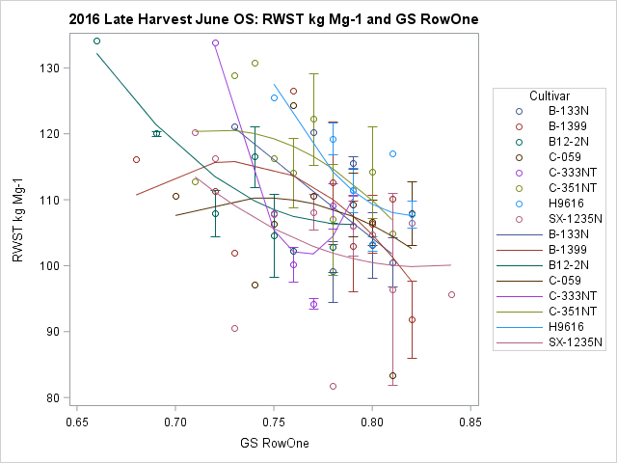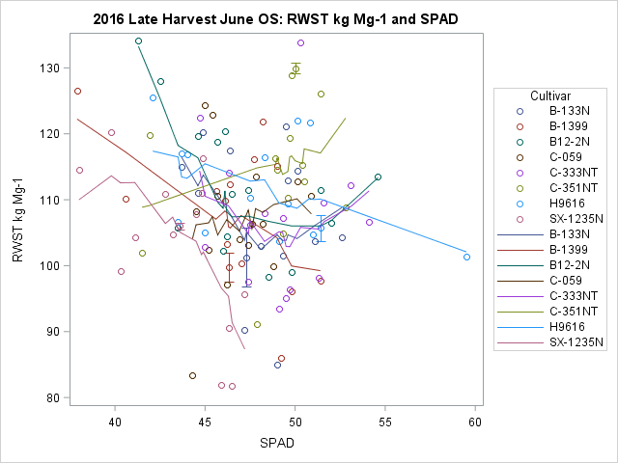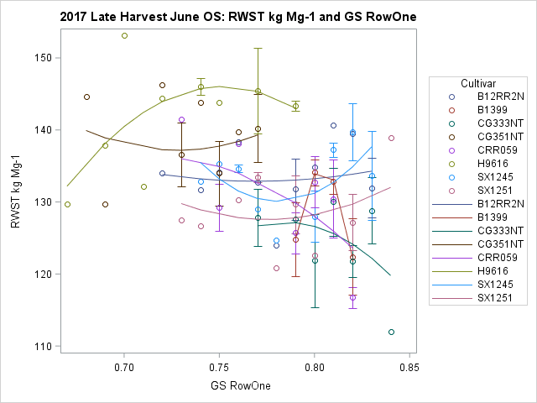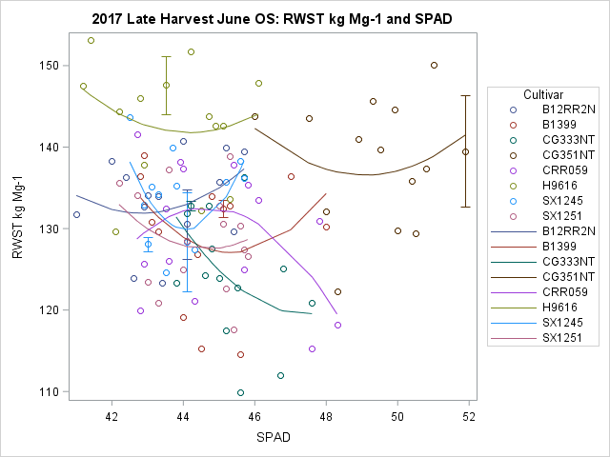

C D

B

A

N applied (kg ha-1) RWST (kg ha-1) RSWT (Mg ha-1)

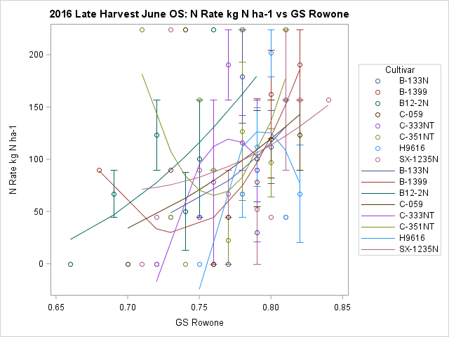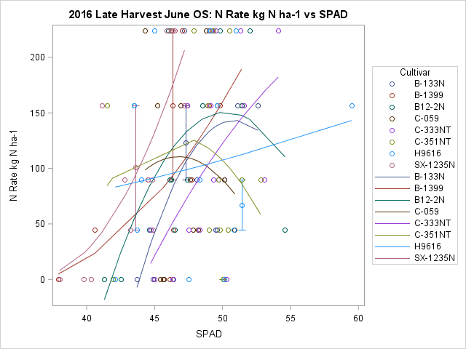

F

E

SPAD reading Greenseeker reading

**Fig. S4.** Cultivar relationship of optical sensor readings from SPAD meter (left) and Greenseeker (right) taken in June with recoverable white sucrose per tonne (RWST) at late harvest in 2017 (A, B) and 2016 (C, D) and with in-season nitrogen fertilizer (E, F) in 2016. Note the change in scale in each panel.

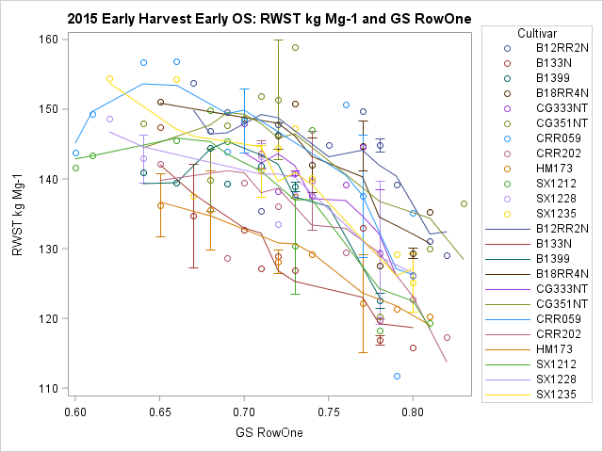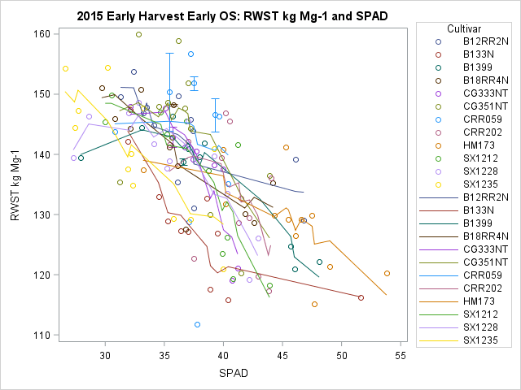

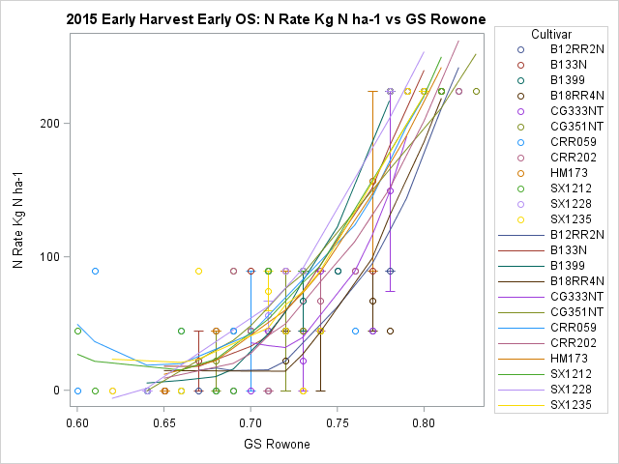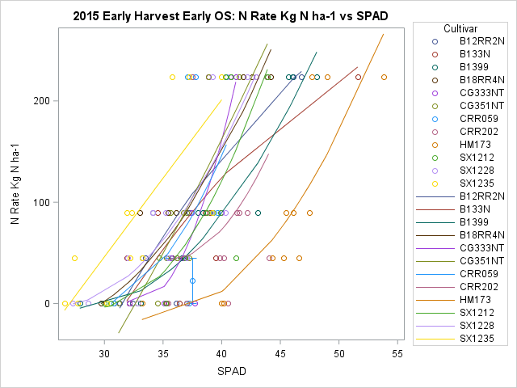

B

D

C

A

SPAD reading Greenseeker reading

**Fig. S5.** Relationship of optical sensor readings from SPAD meter (left) and Greenseeker (right) taken on the day of early harvest with recoverable white sucrose per tonne (RWST) at early harvest (A, B) and in-season, injected nitrogen fertilizer (C, D) in 2015.

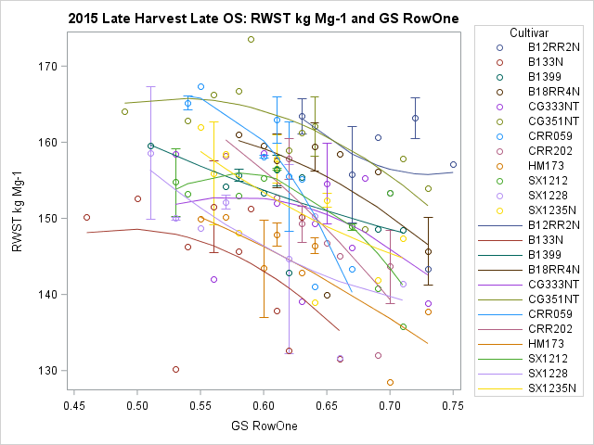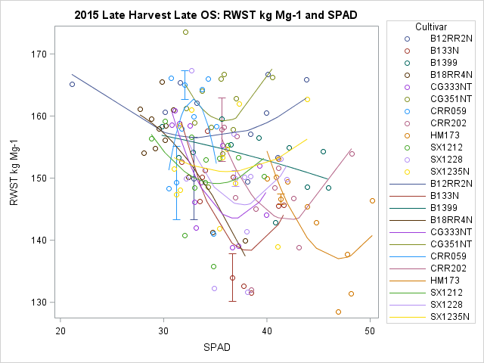

A

B

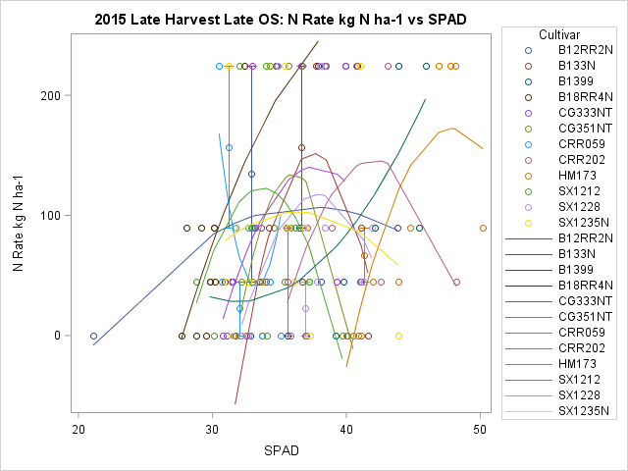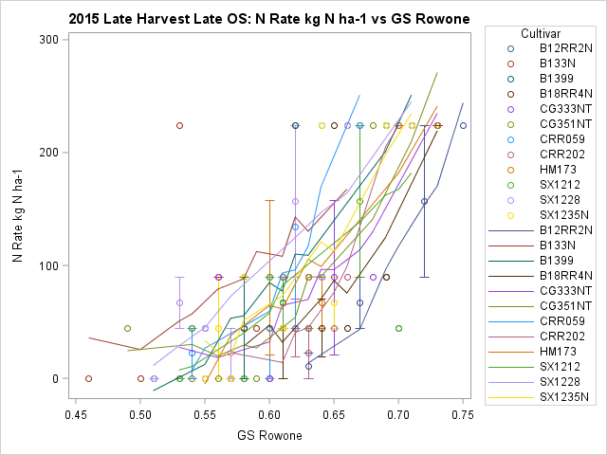

C

D

SPAD reading Greenseeker reading

**Fig. S6.** Relationship of optical sensor readings from SPAD meter (left) and Greenseeker (right) taken on the day of late harvest with recoverable white sucrose per tonne (RWST) at late harvest (A, B) and in-season, injected nitrogen fertilizer (C, D) in 2015.