Supplementary material
Field Data Collection
2.1 Experimental site and design
An N rate response study was conducted from 2010 to 2012 on a Brookston clay loam-a poorly drained lacustrine soil (fine loamy, mixed, mesicTypicArgiaquoll, USDA Soil Taxonomy)in Woodslee, Ontario, Canada (42º13' N, 82º45' W). The average soil texture in the top 0.15 m layer was 28 wt.% sand, 35 wt.% silt and 37 wt.% clay with a soil pH ranging from 6.1 to 6.5. The 30-year mean annual air temperature and precipitation was 8.7℃ and 827 mm, respectively (Shi et al., 2012). Surface slopes were <0.5% at the field site.The fertilizer N treatments included: (1) N0 (0 kg N ha^{‒1}), (2) N50 (50 kg N ha^{‒1}), (3) N100 (100 kg N ha^{‒1}), (4) N150 (150 kg N ha^{‒1}), and (5) N200 (200 kg N ha^{‒1}). All N fertilizers were applied at side-dress at a depth of 0.08-0.10 m approximately 0.15 m on either side of the crop row. This occurred when the maize was at about the six-leaf stage in late May to mid‒June.Each treatment had four replicates and the plots were laid out using a randomized complete block designwith individual plot areasbeing 300m² (30 m long by 10 m wide). These plots were managed using a reduced tillage system which included using adisc tandem (TI009) at a depth of 0.076 – 0.10 m, and a Triple K/Field Cultivator with 0.064 m duck feet shovels (TI011) at a depth of 0.05-0.08 m. Atrazine was applied at 0.84 kg ha^{‒1}inmid-June to control weeds. The maize cultivar used in this research was a Pioneer 35F40 (Pioneer) with a yield potential of 8.7-11.9 tonnes ha⁻¹. Maize seeds were planted using the Kinze no-till planter at a 0.035 m depth (no spring tillage). The plant density was 76,000 seeds per hectarein all years with 0.762 m row spacing. Maize grain was harvested (4 rows by 30 m length) with a Case IH 1620 combine.
2.2. Sampling and analysis
Daily weather data was obtained from the weather station adjacent tothe field plots. The above-ground biomass was measured 4 to 5 times during the maize growing seasons (May to October) from 2010 to 2012 by harvesting all plants in 2 m sections of one row in each plot (i.e., ~10 plants). The plants were dried at 50℃ in the oven to a constant weight and then the above-ground biomass was calculated based on the plant density in each year. The final maizegrain yield was measured annually by harvesting 30 m lengths of the 4 middle rows of each plot. Also, maize grain sub-samples were taken to determine grain moisture, and the grain yield was normalized to 14.5% grain moisture content. Grain dry yield was calculated for model evaluation.
Average volumetric soil water contents at 0.1, 0.4, 0.6, 0.8 and 1.1 m soil depths were measured using Decagon 5TE soil moisture and temperature sensors(Decagon, http://www.decagon.com) during the 2010 to 2012 growing seasons. The total soil water storagein the 0‒1.1 m soil profile was calculated by summing the total of the corresponding volumetric water content (cm³ cm^{‒3}) in the soil layer i,multiplied by the corresponding soil thickness (mm) for the layer i.
References
Shi, X.H., Yang, X.M., Drury, C.F., Reynolds, W.D., McLaughlin, N.B., Zhang, X.P., 2012. Impact of ridge tillage on soil organic carbon and selected physical propertiesof a clay loam in Southwestern Ontario. Soil Till. Res. 120:1‒7.

Table S1. Growing season and annual precipitation in 2010.

County | SLC | MAY | JUN | JUL | AUG | SEP | OCT | May-Oct | Annual | AUG mean
 |  | (mm) | (mm) | (mm) | (mm) | (mm) | (mm) | (mm) | (mm) | (mm)
Chatham-Kent | 565016 | 113 | 78 | 110 | 17 | 76 | 75 | 470 | 835
Chatham-Kent | 565019 | 109 | 85 | 105 | 15 | 79 | 72 | 464 | 785
Chatham-Kent | 565020 | 114 | 83 | 115 | 17 | 79 | 75 | 482 | 841
Chatham-Kent | 565022 | 106 | 99 | 109 | 14 | 79 | 68 | 475 | 779
Chatham-Kent | 565024 | 109 | 90 | 113 | 13 | 81 | 74 | 481 | 809
Chatham-Kent | 570003 | 107 | 89 | 102 | 12 | 81 | 67 | 457 | 767
Chatham-Kent | 570006 | 106 | 94 | 104 | 14 | 78 | 68 | 464 | 770
Chatham-Kent | 570007 | 111 | 110 | 137 | 13 | 74 | 53 | 499 | 820
Chatham-Kent | 570008 | 107 | 106 | 115 | 12 | 78 | 62 | 480 | 782 | 14
Elgin | 565008 | 112 | 101 | 113 | 33 | 79 | 79 | 517 | 919
Elgin | 565009 | 115 | 103 | 111 | 48 | 74 | 82 | 534 | 902
Elgin | 565010 | 110 | 101 | 116 | 47 | 84 | 83 | 542 | 945
Elgin | 565013 | 115 | 102 | 105 | 55 | 77 | 87 | 542 | 920
Elgin | 565014 | 115 | 90 | 115 | 36 | 77 | 79 | 513 | 891
Elgin | 565015 | 111 | 100 | 115 | 43 | 79 | 81 | 529 | 910
Elgin | 565017 | 117 | 89 | 121 | 21 | 80 | 79 | 507 | 877
Elgin | 565018 | 117 | 82 | 119 | 22 | 79 | 77 | 495 | 870
Elgin | 567008 | 114 | 103 | 105 | 53 | 85 | 89 | 548 | 936
Elgin | 568008 | 115 | 109 | 99 | 56 | 69 | 84 | 533 | 887
Elgin | 568010 | 116 | 106 | 102 | 58 | 73 | 88 | 543 | 908 | 43
Essex | 570010 | 127 | 119 | 143 | 9 | 91 | 54 | 543 | 871
Essex | 572001 | 113 | 105 | 148 | 14 | 67 | 50 | 496 | 834
Essex | 572002 | 111 | 104 | 140 | 15 | 70 | 51 | 490 | 818
Essex | 572003 | 115 | 108 | 150 | 12 | 70 | 50 | 505 | 844 | 12
Lambton | 565012 | 101 | 72 | 103 | 26 | 90 | 66 | 456 | 763
Lambton | 567001 | 106 | 85 | 104 | 10 | 89 | 76 | 470 | 867
Lambton | 570001 | 108 | 73 | 98 | 15 | 80 | 71 | 445 | 790 | 17
Middlesex | 565002 | 101 | 80 | 93 | 8 | 93 | 74 | 447 | 823
Middlesex | 565004 | 108 | 74 | 96 | 15 | 82 | 74 | 449 | 819
Middlesex | 565005 | 112 | 87 | 103 | 15 | 72 | 75 | 464 | 848
Middlesex | 565006 | 112 | 105 | 108 | 21 | 76 | 78 | 499 | 899
Middlesex | 565011 | 113 | 89 | 107 | 21 | 73 | 76 | 478 | 863
Middlesex | 567003 | 105 | 96 | 99 | 14 | 87 | 78 | 479 | 870
Middlesex | 567006 | 105 | 116 | 89 | 39 | 96 | 89 | 534 | 909
Middlesex | 567007 | 108 | 109 | 98 | 25 | 86 | 81 | 508 | 898 | 20

Table S2. Soil water balance during the growing season from 2010 to 2012.
Items | Parameters | 2010 | 2011 | 2012
Input | Soil water at day100 | 366 | 366 | 366
 | Precipitation | 451 | 658 | 419
Total |  | 817 | 1024 | 785
Output | Soil water at day320 | 210 | 431 | 231
 | Drainage | 0 | 0 | 0
 | Tile drain flow | 0 | 0 | 0
 | Runoff | 37 | 70 | 49
 | Soil Evaporation | 156 | 125 | 123
 | Transpiration | 414 | 398 | 383
Total |  | 817 | 1024 | 786
 | SOILet | 570 | 523 | 506
 | Potential ET | 692 | 628 | 686
 | Planting | 10146 | 11154 | 12146
 | Harvest | 10320 | 11326 | 12320

Table S3. Simulated maize dry yields (kg ha⁻¹) by soil types by counties in southern Ontario from 2010-2012.
Soils |  | Chatham-Kent |  |  |  | Elgin |  |  |  | Essex |  |  |  | Lambton |  |  |  | Middlesex
 |  | 2010 | 2011 | 2012 |  | 2010 | 2011 | 2012 |  | 2010 | 2011 | 2012 |  | 2010 | 2011 | 2012 |  | 2010 | 2011 | 2012
BERR100001 |  |  |  |  |  |  |  |  |  | 7027 | 9175 | 9574
BERR100002 |  |  |  |  |  |  |  |  |  | 6648 | 9096 | 9825
BERR100003 |  |  |  |  |  |  |  |  |  | 8029 | 9434 | 10845
BERR100004 |  |  |  |  |  |  |  |  |  | 7319 | 8810 | 10150
BRKN100001 |  | 10866 | 10635 | 14047 |  |  |  |  |  | 3929 | 8651 | 6025 |  | 4366 | 8785 | 4975 |  | 6004 | 9254 | 11146
BRKN100002 |  | 11188 | 10635 | 14820 |  |  |  |  |  | 6802 | 9800 | 8494 |  | 4806 | 8902 | 4971 |  | 5883 | 10090 | 11096
BRKN100003 |  | 5368 | 10173 | 12351 |  |  |  |  |  | 3931 | 8667 | 6025 |  | 1804 | 5975 | 5860 |  | 5889 | 8258 | 11143
BVLY100001 |  |  |  |  |  | 6482 | 11570 | 10618 |  |  |  |  |  |  |  |  |  | 7223 | 9340 | 10965
BVLY100002 |  |  |  |  |  | 6486 | 10749 | 11064 |  |  |  |  |  |  |  |  |  | 9600 | 9947 | 9891
BVLY100003 |  |  |  |  |  | 9620 | 11130 | 9992 |  |  |  |  |  |  |  |  |  | 2617 | 6672 | 4773
CLYD100001 |  | 7505 | 11022 | 12653
CLYD100002 |  | 3638 | 8522 | 11103
CSTR100001 |  |  |  |  |  |  |  |  |  |  |  |  |  | 3497 | 8648 | 7309
CSTR100002 |  |  |  |  |  |  |  |  |  |  |  |  |  | 1758 | 5983 | 5860
EMBR100001 |  |  |  |  |  |  |  |  |  |  |  |  |  |  |  |  |  | 7158 | 9132 | 7290
GBLS100001 |  |  |  |  |  | 8011 | 8108 | 6589 |  |  |  |  |  |  |  |  |  | 5656 | 8959 | 7640
GBLS100002 |  |  |  |  |  | 9796 | 9783 | 7862 |  |  |  |  |  |  |  |  |  | 5242 | 7317 | 6059
GBLS100003 |  |  |  |  |  | 11297 | 10483 | 8479 |  |  |  |  |  |  |  |  |  | 4701 | 5910 | 3033
GBLS100004 |  |  |  |  |  | 10444 | 10943 | 9311 |  |  |  |  |  |  |  |  |  | 6431 | 6916 | 6333
HURN100001 |  |  |  |  |  |  |  |  |  |  |  |  |  |  |  |  |  | 5252 | 9869 | 12008
HURN100002 |  |  |  |  |  |  |  |  |  |  |  |  |  |  |  |  |  | 7422 | 7242 | 5266
KNTR100001 |  | 4376 | 9780 | 11603 |  | 6213 | 11249 | 12315
NRMD100001 |  | 6021 | 9583 | 11547 |  | 11228 | 12039 | 15126
NRMD100002 |  | 7031 | 8971 | 12006 |  | 6668 | 11623 | 13313
PFLD100001 |  |  |  |  |  | 9826 | 7795 | 7338
PFLD100002 |  |  |  |  |  | 10186 | 9302 | 8134
PRTH100001 |  |  |  |  |  |  |  |  |  | 6777 | 9142 | 8409 |  | 6846 | 9487 | 7364 |  | 8248 | 8578 | 6907
PRTH100002 |  |  |  |  |  |  |  |  |  | 5961 | 8953 | 8985 |  | 5478 | 9263 | 8338 |  | 9249 | 9922 | 8695
PRTH100003 |  |  |  |  |  |  |  |  |  | 5245 | 8485 | 8398 |  | 4732 | 7234 | 6701 |  | 10325 | 9868 | 9042
TLDO100001 |  | 6581 | 10039 | 10506
TLDO100002 |  | 3832 | 7986 | 7997
TLDO100003 |  | 6033 | 9026 | 8970
TLDO100004 |  | 5397 | 8073 | 8642
TLDO100005 |  | 4099 | 7477 | 6973
TSTK100001 |  | 3943 | 7321 | 5680
TSTK100002 |  | 5211 | 9809 | 12008
TSTK100003 |  | 6190 | 11210 | 12315
TSTK100004 |  | 3928 | 8651 | 6025
TSTK100005 |  | 6798 | 9800 | 8494
WLHM100001 |  | 3930 | 8667 | 6025 |  |  |  |  |  |  |  |  |  | 5252 | 9869 | 12008 |  | 10616 | 10451 | 8341
Ymax |  | 11188 | 11210 | 14820 |  | 11297 | 12039 | 15126 |  | 8029 | 9800 | 10845 |  | 6846 | 9869 | 12008 |  | 10616 | 10451 | 12008
Ymin |  | 3638 | 7321 | 5680 |  | 6213 | 7795 | 6589 |  | 3929 | 8485 | 6025 |  | 1758 | 5975 | 4971 |  | 2617 | 5910 | 3033
Mean |  | 5706 | 9069 | 9790 |  | 9498 | 9800 | 8776 |  | 6651 | 9069 | 9307 |  | 4282 | 8238 | 7043 |  | 7054 | 8646 | 7882
County mean |  | 8188 |  |  |  | 9358 |  |  |  | 8342 |  |  |  | 6521 |  |  |  | 7861

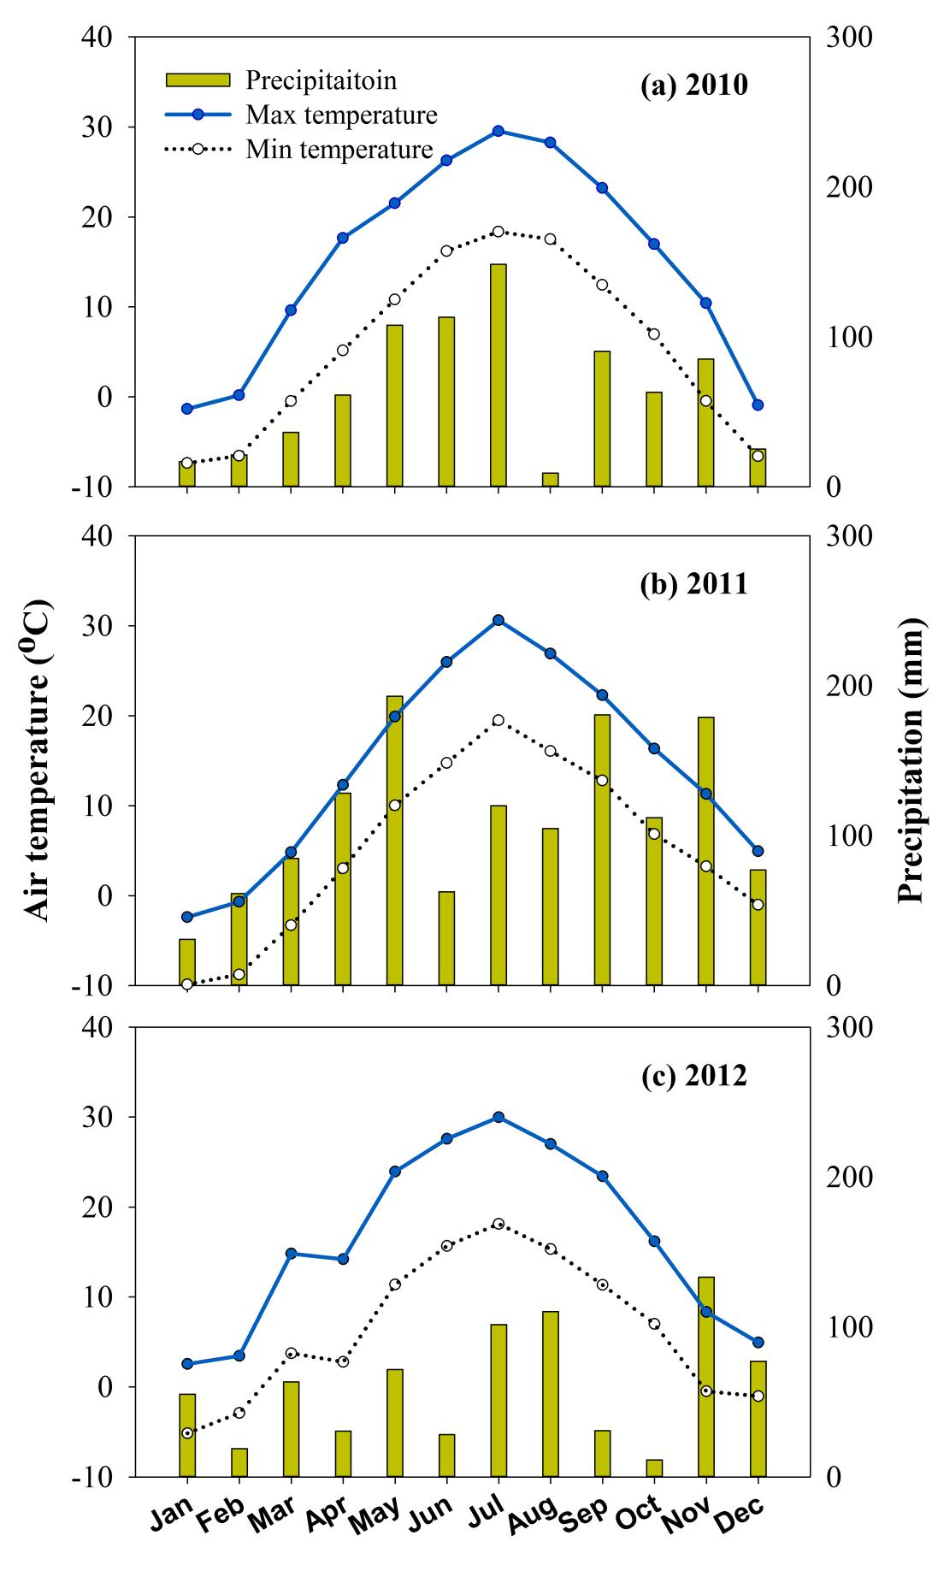
Fig. S1. Monthly precipitation, maximum and minimum air temperature at Woodslee, Ontario during 2010-2012.

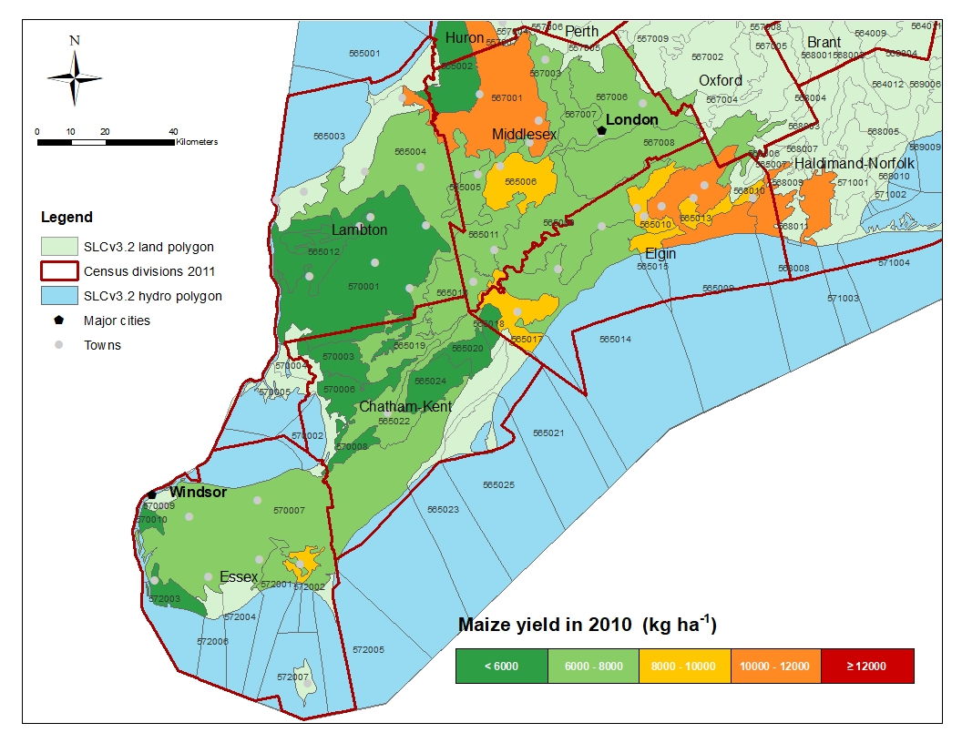
Fig. S2-a. Simulated maize yield distribution maps across 5 counties of southern Ontario in 2010.Woodslee is located 11 km northeast of Essex township.The base map is the Soil Landscapes of Canada v3.2, projected in Canada Lambert Conformal Conic system using the NAD83 datum.

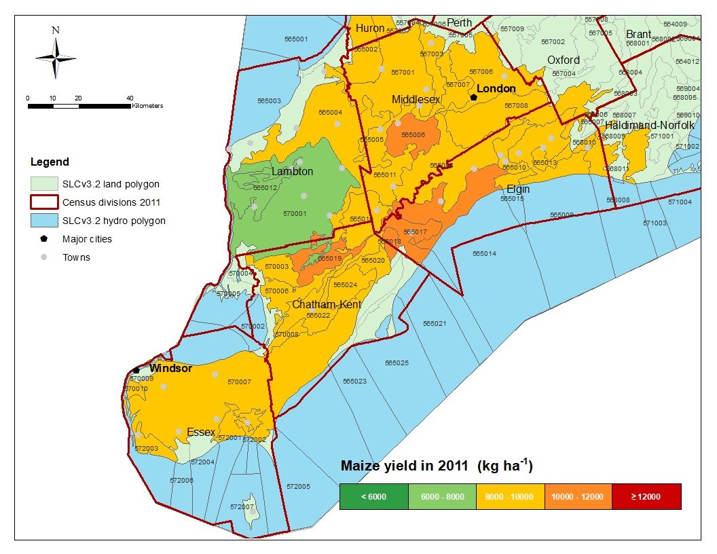

Fig. S2-b. Simulated maize yield distribution maps across 5 counties of southern Ontario in 2011. Woodslee is located 11 km northeast of Essex township.The base map is the Soil Landscapes of Canada v3.2, projected in Canada Lambert Conformal Conic system using the NAD83 datum.

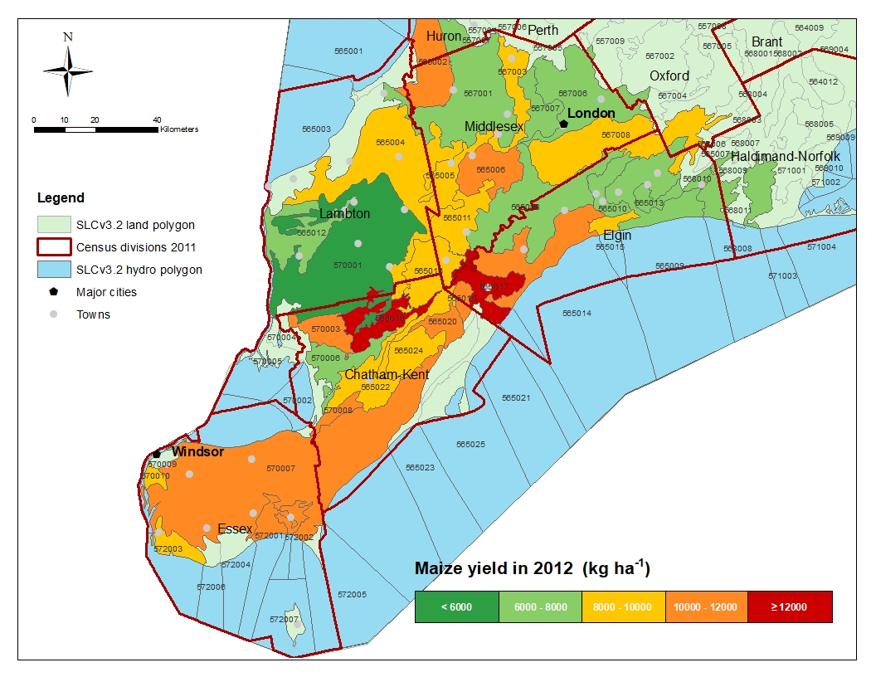

Fig. S2-c. Simulated maize yield distribution maps across 5 counties of southern Ontario in 2012. Woodslee is located 11 km northeast of Essex township.The base map is the Soil Landscapes of Canada v3.2, projected in Canada Lambert Conformal Conic system using the NAD83 datum.

